Cambridge International Project Qualification 2024

IPQ Title: Fracture Behavior of Brittle Rods: Why Chalk does not break in half

Learner name:
Centre Number：
Candidate Number:

Abstract
This research proposed an interpretation of fractures of brittle rods when dropped onto hard surfaces. Experiments on blackboard chalks were conducted to investigate the factors that influenced the fracture behavior. The fracture surfaces of chalks in different materials were observed by utilizing an optical microscope. The real-time fracture process was recorded by cameras. When drop height ranges from 20 cm to 50 cm, chalk does not fail at the first contact with ground, but fail at the subsequent hit between the other end and ground with a higher angular velocity by rotating itself due to a torque produced from the first hit. When chalk drops at a height greater than 50 cm with a ground angle greater than 60°, chalk fail due to the shear stress produced in the first contact with ground.

Keywords: free fall; fracture mechanics; cascading fracture; chalk

Contents
Abstract 2
1. Introduction 4
2. Literature review 6
2.1 Fracture Mechanics for brittle materials 6
2.2 Materials and mechanical Properties of blackboard chalk 11
2.3 Failure analyses and morphology 14
3. Experimental 20
3.1 Materials 20
3.2 Equipment 20
3.3 Experiment Setup 22
3.4 Tests 23
3.4.1 Test overview 23
3.4.2 The effect of material on chalk fracture. 24
3.4.3 The effect of dropping height on chalk fracture 25
3.4.4 The effect of ground angle on chalk fracture 26
4 Results 27
4.1 The effect of materials on chalk fracture 27
4.2 The effect of dropping height on chalk fracture 29
4.3 The effect of ground angle on chalk fracture 32
4.4 Interpretation of cascading fracture 37
5 Conclusion 42
6 Review and Evaluation 44
References 45
Appendix 48
Appendix A: resource evaluation form 48
Appendix B: Pictures and videos 50
Appendix C: Initial Mindmap and Gantt Chart 53

Introduction
The author’s attention has been long drawn to the unusual phenomenon of the fracture of cylindrical brittle rods such as chalk when dropped onto the ground, as it usually breaks into three or more pieces instead of only two. Previous researches have mainly focused on the cascading fracture of elongated elastic rods when slowly bent beyond their limit curvature. However, relatively less attention has been directed to the cascading fracture of brittle rods receiving a sudden impact when hitting and dropping onto hard surfaces. This paper seeks to extend current research and give theoretical explanations of this unique process by methods of experiment.
Fracture is the separation of an object or material into two or more fragments under the action of stress. The physical process of fracture is immanent in nature, from earthquakes to the breaking of bones, and is relevant to several fields in science and technology. Understanding and controlling the fracture process is one of the foremost theoretical and practical challenges in science and engineering and has direct applications to our daily life. Previous papers have claimed that the cascading fracture of elongated elastic rods, such as spaghetti, are due to the flexural waves produced at the first breaking point. The waves will create further curvature beyond the limit curvature, hence causing the fracture to cascade simultaneously. However, the article failed to explain why cylindrical brittle rods will also have cascading fractures under a sudden impact, as it always breaks at its antinodes and is hard to form waves. Another research was limited to a qualitative description and hypothesis on the process of chalk breaking and was not able to give any detailed quantitative descriptions of the process.
This paper attempts to put forward a physical interpretation of why brittle cylindrical rods will break into multiple pieces rather than two pieces when dropped onto hard surfaces. We refer to this kind of rod as brittle since they have no yield point and present a straight line on the stress-strain graph. In the pages that follow, experiments will be conducted on different kinds of chalk and will probe into the factors that influence the fracture process. The fracture process and phenomenon will be recorded and described in details in order to seek a proper explanation. The brittle fracture surface will be observed and compared using a microscope to determine the type and cause of fracture. Furthermore, a detailed interpretation of the cascading fracture process will be put forward based on the data obtained from the experiment.
This study contributes to the literature in two ways. First, this research explores the fracture process of rods in a non-static situation under free fall. Second, The study enriches innovation studies by exploring the cascading fracture process of cylindrical brittle rods. In this study, we particularly focus on brittle cylindrical rods as they behave very special under impacts as they hardly yield and are elastic under stress. To the best of our knowledge, this study is among the first to investigate this unique process.
This paper is organized as the following. In the literature review part that follows the introduction, we will describe fracture mechanics for brittle materials, the mechanical properties and materials of blackboard chalk and failure analyses and morphology. Next, experiments will be designed and conducted to analyze the factors that will influence the fracture process. Finally, a proper interpretation will be put forward to explain this unusual phenomenon.

Literature review

Fracture Mechanics for brittle materials
Fracture mechanics is the field of mechanics concerned with the study of the formation and propagation of cracks in materials (Anderson,1995). It uses methods of analytical solid mechanics to calculate the driving force on a crack and those of experimental solid mechanics to characterize the material's resistance to fracture. In fracture mechanics, there are three types of fracture: mode I (tensile fracture), mode II (shear fracture), and mode III (out-of-plane tearing fracture).
A fracture is the separation of an object or material into two or more pieces under the action of stress (σ) and strain (ε) (Ewalds &Wanhill, 1984). Any fracture process involves two steps, crack formation and propagation, in response to an imposed stress. Stress is a physical quantity that expresses the internal forces that neighboring particles of a continuous material exert on each other, while strain is the measure of the deformation of the material. For a straight rod with uniform material and cross section, tensile stress is subjected to tension by opposite forces of magnitude F along its axis with the signal σ. Mathematically,
. (1)
Strain represents the displacement between particles in the body relative to a reference length. The numerical value of strain is the ratio of total deformation to the initial dimension of the material body on which forces are applied (Hayre, 2014). Mathematically,
. (2)
The fracture of a material can be caused by either ductile fracture or brittle fracture. Before a ductile fracture, the material undergoes considerable plastic deformation (necking). Due to the absorption of a substantial amount of energy before fracture, the extensive flexibility causes the crack to propagate slowly. Ductile fracture is usually caused by the fatigue of the material. However, brittle materials absorb relatively little energy prior to fracture and break with little elastic deformation and without significant plastic deformation. This is a consequence of the spontaneous and rapid crack propagation, which will usually cause the fracture to be accompanied by large snapping sounds (Buckley, 2005). Brittle fracture typically involves little energy absorption and occurs at high speeds. The mode of fracture is highly dependent on the mechanism of crack propagation. For brittle materials, cracks are unstable, meaning that crack propagation, once started, continues spontaneously without an increase in stress level. Cracks propagate rapidly (speed of sound) and occur at high speeds. It should be noted that generally speaking, the smaller the grain size, the better a material withstands dislocation or crack. In particular, smaller grain sizes, higher temperatures, and lower stress tend to mitigate crack initiation. Larger grain sizes, lower temperatures, and higher stress tend to favor crack propagation (Terry, 2011). There is a stress level below which a crack will not propagate at any temperature. This is called the lower fracture propagation stress.
The stress-strain curve of a material for a material gives a graphical relationship between stress and strain. The diagram is able to reveal and examine the mechanical properties such as the Young's modulus, the yield strength and the ultimate tensile strength (UTS) as well as predict the type of fracture it will undergo. The following picture is a stress-strain curve typical of low carbon steel.
Fig 1. Stress-strain curve of low-carbon steel (Courtney & Thomas, 2005)
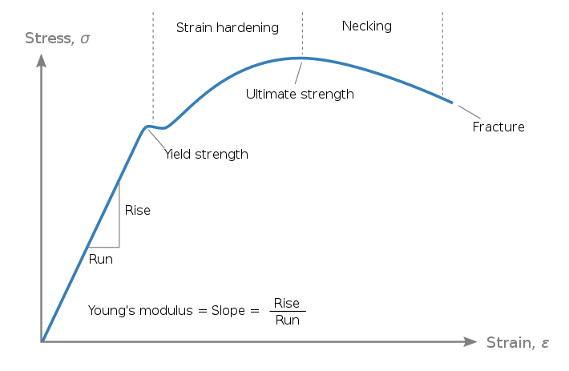
The stress-strain curve of a kind of material is usually divided into three stages different stages have different forms, implying that the mechanical properties are different. Materials may be missing one or more of the phases illustrated, and they may behave at completely different levels.
The initial stage is the linear elastic area, where the stress is proportional to the strain, following Hooke's law in general, and the slope is Young's modulus. The material undergoes only elastic deformation in this region, with the beginning of plastic deformation occurring at the stage's end. The yield strength of this location is defined as the stress component (or upper yield point, UYP for short).
The second stage is the strain hardening region. This region starts as the stress goes beyond the yielding point, the grains are elongated along the direction where the deformation is greatest, reaching a maximum at the ultimate strength point, which is the maximal stress that can be sustained and is called the ultimate tensile strength (UTS). In this region, the stress mainly increases as the material elongates, except that for some materials such as steel, there is a nearly flat region at the beginning.
The final stage is the necking region. Beyond tensile strength, a neck forms when the local cross-sectional area becomes significantly smaller than the average. The necking deformation is heterogeneous and will reinforce itself as the stress concentrates more in a small section. As a result of this positive feedback, necking develops quickly and fractures occur.
For most ductile materials, the stress-strain graph is long curve having all three stages with a large maximum strain and UTS. The area under curve is relatively large, indicating that large amount of energy is required for the material to fracture. Most curves exhibit a yield point. Plastic flow initiates at the upper yield point and continues at the lower one. At lower yield point, permanent deformation is heterogeneously distributed along the sample. The deformation band which formed at the upper yield point will propagate along the gauge length at the lower yield point. After the yield point, the curve typically decreases slightly and end with a necking.
For brittle materials, the stress-strain graph is a short straight line having only the first stage with a low maximum strain and UTS. The area under curve is relatively small, showing that little energy is required for fracture. Brittle materials do not have a well-defined yield point, and do not strain-harden. The rupture occurs without any noticeable prior change in the rate of elongation, and sometimes they fracture before yielding. Therefore, the ultimate strength and breaking strength are the same. Typical brittle materials do not show any plastic deformation but fail while the defiin a sormation is elastic. One of the characteristics of a brittle failure is that the two broken parts can be reassembled to produce the same shape as the original component as there will not be a neck formation like in the case of ductile materials. A typical stress-strain curve for a brittle material will be linear. For some materials, tensile strength is negligible compared to the compressive strength and it is assumed zero in most circumstances.
Chalk is a typical brittle material. The stress-strain graph has a small elastic region and has no yield point. Under normal conditions, chalk does not undergo ductile fracture (Mortimore, 2004).
Brittle materials have high strength in comparison to ductile materials. Brittle materials are stronger in the compression and absorb relatively little energy prior to fracture, even those of high strength.
Toughness is an essential identity of a material and is a crucial property in fracture. Generally speaking, toughness is the ability of a material to absorb energy and plastically deform without fracturing. Two types of toughness are often used in fracture analysis, fracture toughness and impact toughness.
Fracture toughness refers to a property which describes the ability of a material containing a crack to resist further fracture. Fracture toughness is a quantitative way of expressing a material's resistance to brittle fracture when a crack is present.
Impact toughness is the ability of a weld to permanently deform and absorb energy before fracturing, after applying rapid stress to it. Simply stated, it's how much rapid impact energy a weld can take before it cracks. The application of the stress is typically under one second. The impact toughness of a meterial is determined by measuring the energy absorbed in the fracture of the specimen. This is simply obtained by noting the height at which the pendulum is released and the height to which the pendulum swings after it has struck the specimen. In the case of the fracture of brittle rods, most fractures are impact fractures.

Materials and mechanical Properties of blackboard chalk
Chalk rods used in teaching today can be classified into two major categories: normal chalk and dustless chalk. More than 90% of the types of normal chalk is made of calcium sulfate (CaSO4), which is derived from gypsum (CaSO4-2H2O), an evaporite mineral formed by the deposition of ocean brine. Normal chalk also contain small amounts kaolin clay, Oleic acid, and Sodium hydroxide. Chalk and dehydrated gypsum thus have similar origins and properties. Pastels also contain clays and oils for binding, and strong pigments. This mixture produces sticks that write smoothly without smearing and draw better on paper than on chalkboards. Although great care is taken to eliminate contaminants when chalk is manufactured, some impurities inherent to the mineral remain. Chief among these are silica, alumina, iron, phosphorus, and sulfur. In less significant, amounts, manganese, copper, titanium, sodium oxide, potassium oxide, fluorine, arsenic, and strontium may also occur (Boynton&Robert, 1980). A small amount of the types of chalk are composed of mineral chalk, which is mostly composed of carbon carbonate (CaCO3).
Colored chalks, pastel chalks, and sidewalk chalk (shaped into larger sticks and often colored), used to draw on sidewalks, streets, and driveways, are primarily made of gypsum rather than calcium carbonate chalk.
As calcium sulfate (gypsum) based normal chalks are widely used for teaching, More and more schools began to adopt a new kind of dustless chalk. In contrast, dustless chalks are manufactured, using a high-pressure extrusion process with polymeric binders, in developed countries like the USA, UK, EU countries, and Korea (Nasir, 2002). The main raw materials for dustless chalk is a mixture of calcium carbonate and calcium sulfate (gypsum) with the addition of polymeric binder so that they can adhere more closely to do the deed of dust-free, e.g., PVA, PVP, starch, etc. The weight and density of these chalks are approximately twice than that of gypsum-based chalk, it may cause some discomfort when writing. In addition, the abrasion rate of dustless chalk was less compared to normal chalk. The essential raw materials for the production of blackboard chalk include chalk variety of limestone and gypsum or anhydrite (Sharhan, 1994).
In dustless chalks, the effect of wettability/water penetration in the porous structure of chalks and the use of a surfactant (AOT) to improve the quality of normal chalks. Particle–particle adhesion is stronger in dustless chalks, which generate large particles during the writing or erasing process (Thakker, 2015). Though it has a larger grain size, it also has a greater impact toughness as they have better bounding.
On a microscopic scale, chalks are mainly built up of whole and fragmentary skeletons produced by planktonic algae known as coccolith phorids. The building blocks of the skeletons are sulfite tablets or platelets of a typical dimension 1µm. These sulfite grains are arranged in rings or rosettes known as coccoliths, typically 10 µm in diameter. Pure high porosity chalks consist of a mixture of intact coccolith rings and greater and smaller fragments. This gives the chalk material a rather open structure, where the dimensions of the pore space may be considerably greater than the dimensions of the individual grains. On the other hand, the smallness of the grains make the pore throats rather narrow, and the permeability of even high porosity chalks is typically only a few mDs (Risnes1&Flaageng, 1999).
Fig 2. Shear stress vs normal stress graph of chalk (Mortimore, 2004)
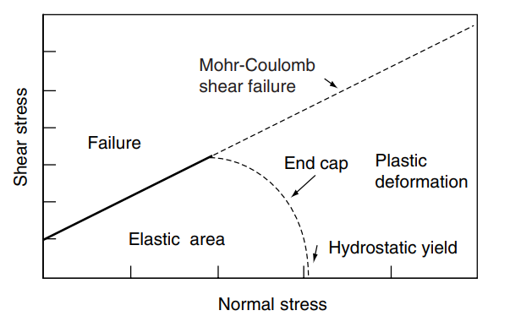
Mechanically, chalks behave as brittle and frictional materials, failing in a shear or tensile failure mode. However, the open structure of these chalks enhances another failure mechanism, often referred to as pore collapse. Chalk grains may relatively easily be forced into the pore space, resulting in a kind of internal implosion. This type of failure may take place even under hydrostatic loading when no macroscopic shear stresses are present. But shear stresses at a microscopic level may well develop and start this type of deformation. With these two types of failure modes chalks may mechanically be described by a Mohr-Coulomb type failure criterion with an end cap (Mortimore, 2009). Chalk is a brittle material and is likely to fail under sudden stress. Chalk is more likely to fail under shear stresses or tensile stresses, and have a greater toughness against compression stress.

Failure analyses and morphology
In materials science, failure can be categorized into five types: fracture, corrosion, wear, distortion and attenuation. In this paper, we will only focus on the fracture type of failure of a material. Fracture is usually caused by external force or stress and the type of failure is strongly related to the magnitude and type of stress. There are five main types of stress: tensile stress, compression stress, shear stress, bending stress, and torsional stress. The type of stress and force that the object experiences can be deduced from analyzing the fracture section (fracture morphology). For ductile materials, failure occurs at the onset of plastic deformation. For brittle materials, failure occurs at fracture.
The fracture of a solid usually occurs due to the development of certain displacement discontinuity surfaces within the solid. If a displacement develops perpendicular to the surface, it is called a normal tensile crack or simply a crack; if a displacement develops tangentially, it is called a shear crack, slip band, or dislocation.
Tensile stress is caused when axially-loaded forces are pulling away from an object's center, and perpendicular to the object's surface. Tensile stress is a type of normal stress, so it acts at 90 degrees to the area. Tensile stress can cause the lengthening of an object for ductile materials.
The most common type of tensile fracture profile for ductile metals is that where the fracture is preceded by only a moderate amount of necking. The fracture process normally occurs in several stages (see figure 4). First, after necking begins, small cavities, or microvoids, form in the interior of the cross-section. Next, as deformation continues, these microvoids enlarge, come together, and coalesce to form an elliptical crack, which has its long axis perpendicular to the stress direction. The crack continues to grow in a direction parallel to its major axis by this microvoid coalescence process. Finally, fracture ensues by the rapid propagation of a crack around the outer perimeter of the neck. For brittle materials, tensile fracture usually has a fracture surface perpendicular to the direction of stress without necking. By reassembling the fractured pieces of the material, the fractured pieces will produce the same shape as original. The following picture shows a tensile fracture in different kinds of materials. In fig 3, (a) shows a highly ductile fracture in which the specimen necks down to a point. (b) shows a moderately ductile fracture after some necking. (c) shows brittle fracture without any plastic deformation.
Fig 3. Tensile fracture in different kinds of materials (Callister & Rethwisch, 2018)
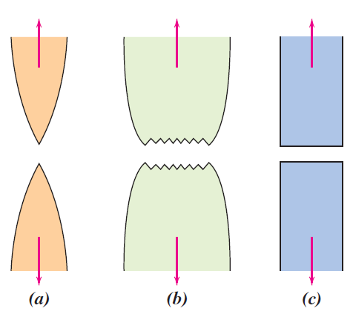
Fig 4 shows stages of a ductile fracture that is put under tensile stress, which is often referred as cup-and cone fracture.
Fig 4. Stages in the cup-and-cone fracture (Callister & Rethwisch, 2018)
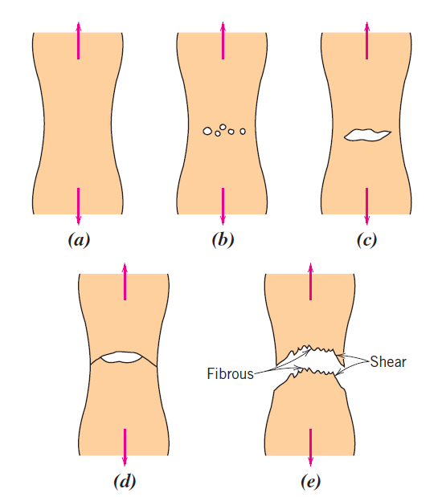
Compression stress is the result of axially-loaded forces pointing towards the center of an object. There are two major issues with compression stress: Compression forces can cause an object to shorten, or they can cause an object to buckle. When an object buckles, it bends in such a way that it can no longer hold the load, even though structurally speaking, the object can hold more stress than is applied to it. For brittle are usually strong under compression stress and will be fragmentary (Rao&Sun, 2016). The following picture shows the fracture of concrete under compression stress.
Fig 5. Fracture of concrete under compression (Huang, Hu & Sun, 2019)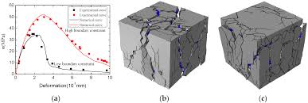
Shear stress, often denoted by the component of stress coplanar with a material cross-section, is caused when the forces applied to an object are parallel to the object's cross-section. This stress can cause the object to deform and, in some cases, pull apart. As the object deforms, it changes. The shape of the object can change, which can affect how the object withstands other forces.
Shear fracture refers to the breakage or disintegration of a material due to the application of a strain force on its surface. Shear fractures occur due to concentrations of stress at flawed locations on a material's surface that are already otherwise susceptible to external attack. These flaws are typically due to reactive attacks like pitting and crevice corrosion. The fracture surface of a brittle material caused by shear fracture is tangential with no plastic necking. A reassemble of the fractured pieces will also produce the original shape. Shear deformation is usually at an angle of about π/4 with the tensile axis—this is the angle at which the shear stress is a maximum (Hayre, 2015). The following picture shows a shear fracturing behavior of sandstone, which is a type of brittle material.
Fig 6. Shear fracture behavior of sandstone (Stephansson & Stillborg, 2003)
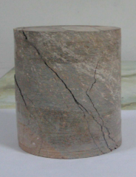
B ending stress is seen in longitudinally-loaded objects. The forces cause the object to bend, usually in a downward direction. The farther away from the object's fixed supports, the greater the bending stress. For a brittle bending fracture, the fracture surface is usually perpendicular to the surface.
For brittle materials, the bending stress can be viewed as a kind of tensile stress, and the fractography of the fracture surface appears to be flush macroscopically and cleavage microscopically.
Torsional stress can be defined as the shear stress that acts on a transverse cross section which is caused by the action of a twist. Torsional shear stress can be thought of as the shear stress produced on a shaft due to twisting. However, it is fundamental to distinguish between the two kind of stress and its relative failure as the toughness and fracture surface related is significantly different.
Fig 7: Torsional fracture of brittle rod (Shimizu & Tsuchiya, 2009)
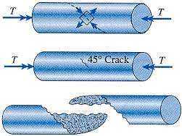
There are few researches done on cascading fracture. For an elongated brittle rod when bent beyond its limit curvature, the first break will create a burst of flexural waves which results from a sudden relaxation of the curvature at the newly released end, whose dynamics are represented by a self-similar solution with no changeable parameters. This counter-intuitive mechanism is responsible for the fragmentation of brittle rods under bending because these flexural waves enhance the curvature of the rod locally. The cascading fracture can be controlled through twisting and quenching.

Experimental

Materials
The experiments aimed to study the fracture behavior of brittle rods by using different kinds of chalk rods. Three types of chalk were bought from jd.com based on its price and descriptions in order to obtain chalk or different toughness. The following table and picture show the parameters and appearance of three types of chalk.
Table 1: The parameters of three types of chalk
Type | Original Length/mm | Radius/cm | Shape | Composition
Chalk A | 80±1 | 10±0.5 | cylindrical | Hardened chalk
Chalk B | 81±1.5 | 9.5±1 | cylindrical | gypsum
Chalk C | 72±2 | Larger end: 10±1  Smaller end:8±1 | hexagonal prism | gypsum
Note: All the data from table 1 is obtained from measurements done by the researcher.
Fig 8. Three types of chalk
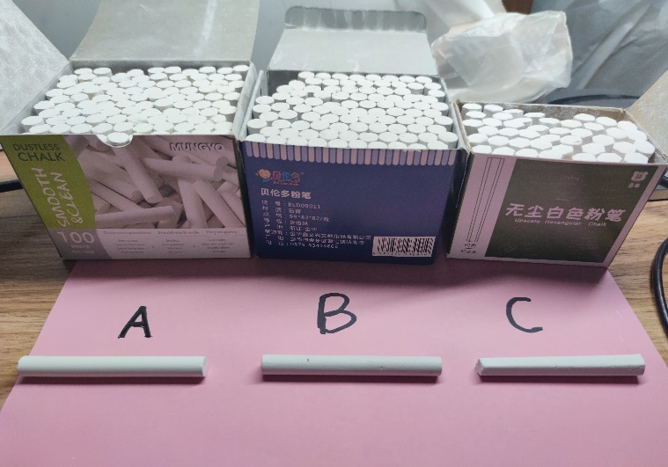

Equipment
The experiment chose a variety of equipment to study and analyze the fracture process as well as supporting the experiment. Cameras were used to film the process of fracture. Previous trials of the experiment had shown that using only one camera might cause the researcher unable to capture the process of fracture due to deviations in camera focus and the angle of filming. Therefore, the researcher chose to use three cameras placed at three different angles to film the process. Cameras B and C were placed on the ground at different angles mainly to film the process of fracture and camera A was placed at a height of 1m to film the whole process. Table 2 shows the parameters of 3 types of cameras:

Table 2: Camera parameters
Name and model | Quad | Video Framerate | Size
Camera A: Xiaomi 10 main | 1080P | 120FPS | 16:9
Camera B: Mate40 main | 4K | 7680FPS | 16:9
Camera C: Ipad pro main | 1080P HD | 340FPS | 4:3
Note: All the data from table 2 is obtained from descriptions provided by the producer.
Microscopes were used to observe and analyze the fracture section and characterization of fracture. The parameters of microscope can be found in the following table.
Table 3: Microscope parameters
Model | Ocular lens | Magnification lens | Objective lens | Work area
Ruihoge  XSP-02-640 | 16× or 25× | 2× | 10×, 40×, 125× | 120×110mm
Note: All the data from table 2 is obtained from descriptions provided by the producer.
The experiment also used a tapeline, a vernier caliper, 2 black tablets, a protractor, 3 flashlights and a small blade. The tapeline (3m/0.1cm) was used to locate the height of free fall. The vernier caliper(15cm/0.05cm) was used to measure the length of the fractured pieces of chalk. 2 Black tablets were used to provide a black such that the videos and pictures filmed could be clear. The protractor (180°/1°) was used to measure the angle between the axis of chalk rods to horizontal ground. 3 Flashlights were used for illumination. A small blade is used for getting powder of chalk.

Experiment Setup
The experiments was set up as the following:
Fig 8. Experimental setup
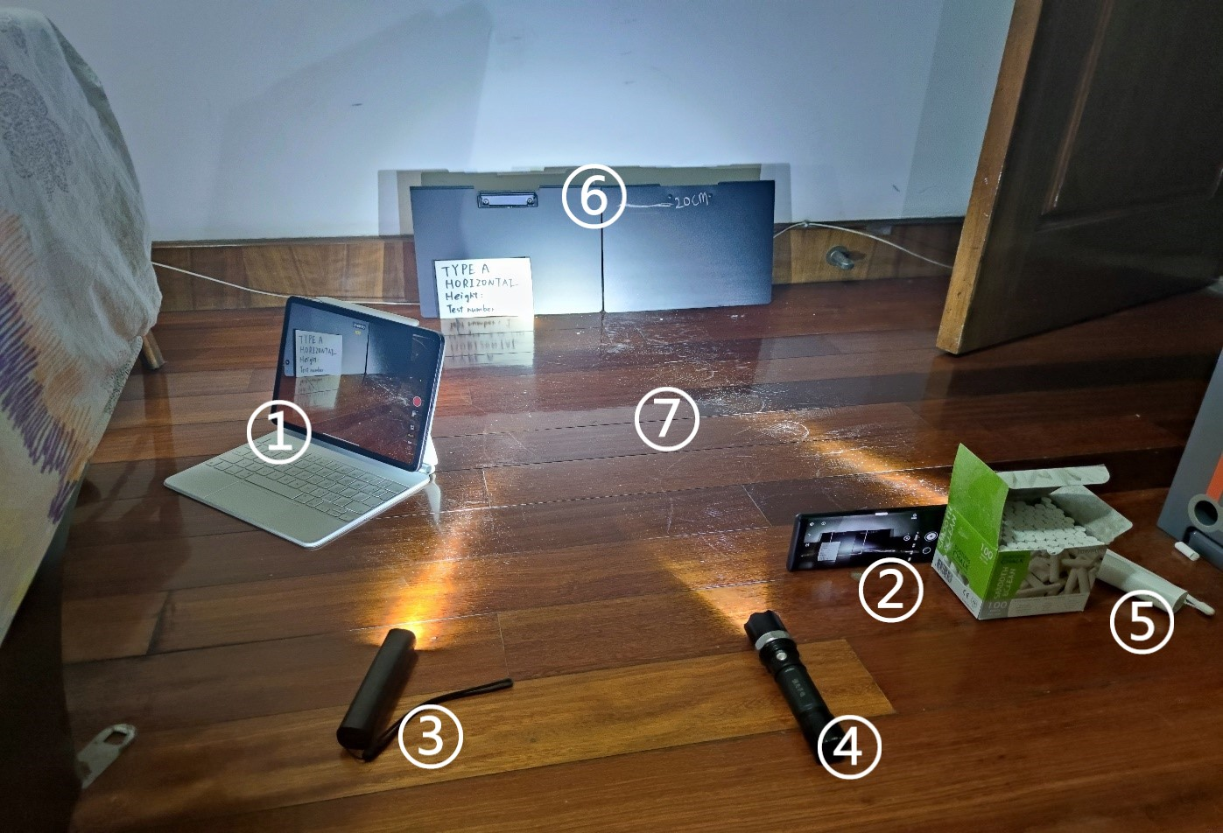
Chalk rods were dropped onto ground at area ⑦ with axis parallel to the background wall. ⑥ were two black tablets that provided a background for the filming. The fracture process was recorded by camera ① and ② at two separate angles ( ① is camera C and ② is camera B): camera ② filmed against the major axis of the chalk while camera ① filmed at an angle of 45° against chalk’s major axis. ③④⑤ were flashlights placed on the ground at three different angles that provided a strong and stable light source for the recording to be clear and full.

Tests

Test overview
The experiments aimed to determine the factors that influence the fracture behavior of brittle rods under free fall by using chalk rods as an example. The fracture behaviors of chalk were tested by dropping a complete chalk with from rest onto horizontal ground. In order to facilitate the subsequent descriptions and explanations, several quantities were defined for this experiment. For each experiment, the vertical distance between the chalk’s center of mass and ground before free fall was defined as “drop height”. The angle between the chalk’s major axis and horizontal ground before free fall was defined as “drop angle”. The angle between the chalk’s major axis and horizontal ground when the chalk initially touches the ground was defined as “drop angle”. Fig 9 is simple a diagram showing the three quantities.
Fig 9. Schematic diagram of 3 quantities
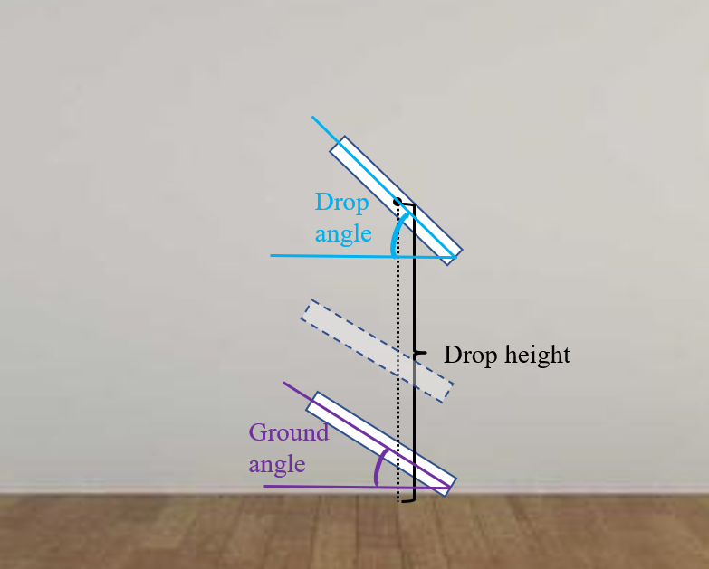
The minimum drop heights needed for each type of chalk to fracture were compared to study the effect of material on chalk fracture. The three types of chalk were dropped at a drop angle of 0° at different heights in order to study the influence of drop height on the fracture of chalk. After studying the effect of drop height on cascading fracture, an additional experiment was conducted to study the effect of ground angle on fracture by changing the drop angle.
The following picture is a roadmap of this experiment.
Fig 10. Test roadmap
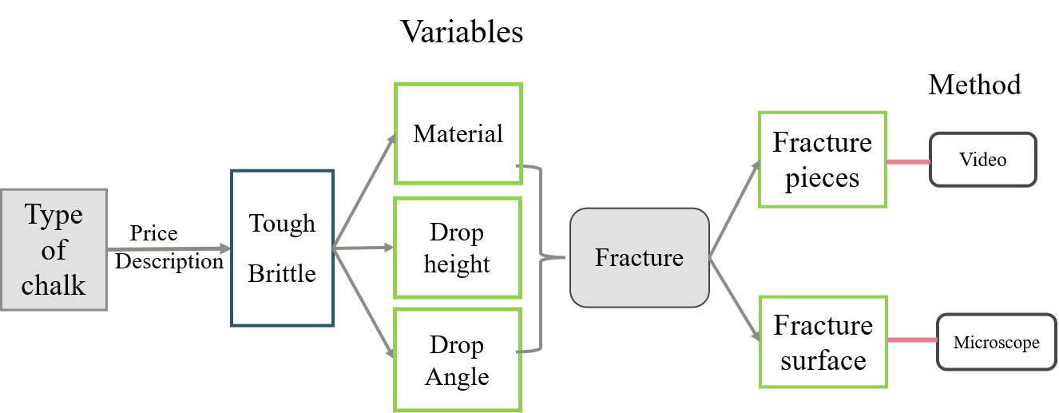

The effect of material on chalk fracture.
Prepositive trials done by the researcher showed that the critical height of each type is ranged from 7.5cm to 20cm. Hence, this test dropped three types of chalk at drop heights of 10cm, 12.5cm, 15cm 17.5cm and 20cm and dropped at a drop angle of 0°. The fracture condition (fractured/complete) was recorded for each drop, and the fracture process was recorded by cameras. For each height, the chalk rods were dropped three times. The result of whether the chalk breaks at this height is determined by the condition that occurs two or more times. The minimum height needed for each type of chalk to break (critical height) was determined and used to compare the impact toughness. Furthermore, the fracture surfaces of three types of chalk were put under a microscope to study.

The effect of dropping height on chalk fracture
Three types of chalk were separately dropped at a drop height of 20cm, 30cm, 40cm, 50cm, 60cm, 70cm and 80cm at a drop angle of 0°. The free fall and fracture processes were recorded by slow-motion cameras, which was used to obtain the ground angle and to study the fracture process. For each drop, the number of pieces after free fall, ground angle, and length of fractured chalk were recorded.
The following picture is a schematic diagram of this experiment.
Fig 11. Experiment schematic diagram at drop angle 0°
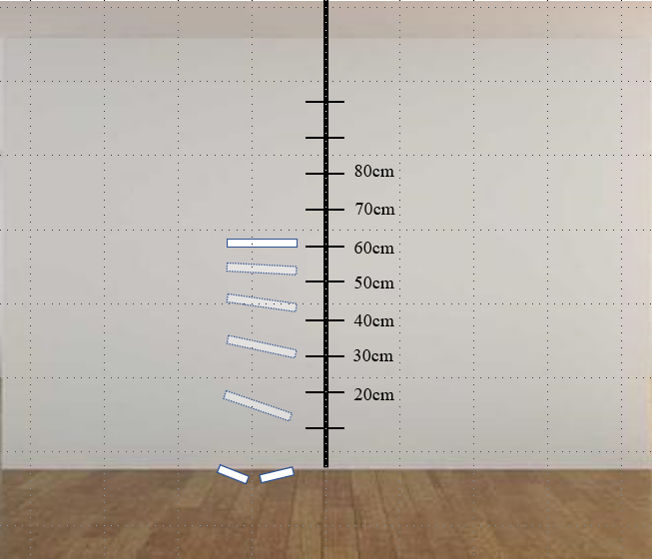

The effect of ground angle on chalk fracture
In order to control variables, this experiment only chose chalk A to drop at a fixed drop height of 50cm. The chalk rods were dropped separately at a drop angle of 45° and 90° for 5 times. The free fall and fracture processes were recorded by slow-motion cameras, which were used to obtain the ground angle and to study the fracture process. For each drop, the number of pieces after free fall, ground angle, and length of fractured chalk were recorded.
The following pictures are schematic diagrams of this experiment.
Fig 12. Experiment schematic diagram at drop angle 45°
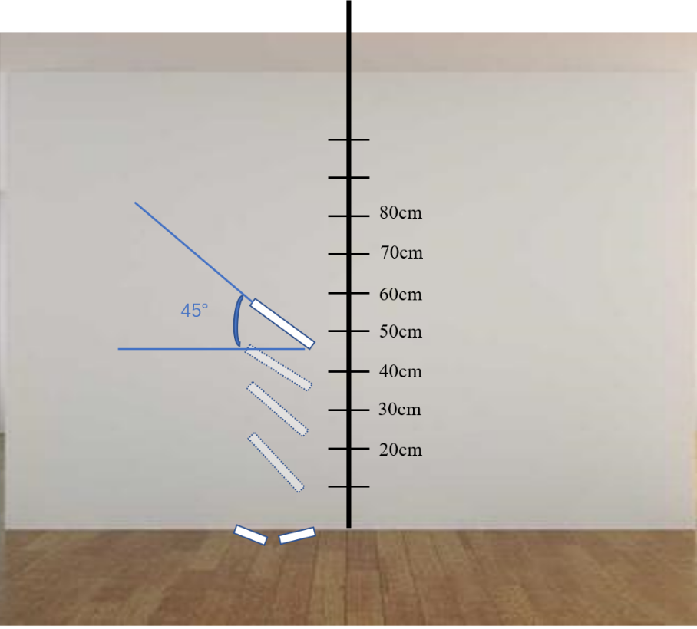
Fig 13. Experiment schematic diagram at drop angle 90°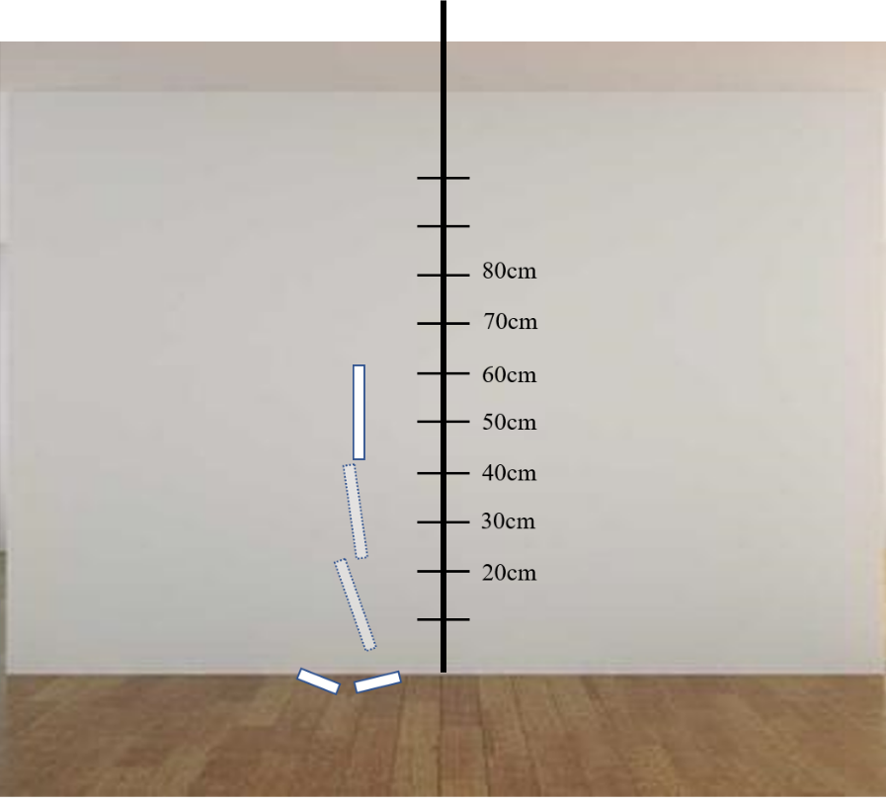

Results

The effect of materials on chalk fracture
For each height, if two or more pieces of dropped chalk fractured, the result is noted as √ ; if two or more pieces dropped chalk fractured, the result is noted as ×.
Table 4: Critical height of each type of chalk
Drop height/cm | Chalk A: | Chalk B | Chalk C
7.5 | × | × | ×
10 | × | √ | ×
12.5 | × | √ | ×
15 | × | √ | √
17.5 | × | √ | √
20 | √ | √ | √
The results show that chalk A has a critical height located between 17.5cm and 20cm; chalk B has a critical height located between 7.5cm and 10cm; and chalk C has a critical height located between 12.5cm and 15cm. This shows that the material of chalk will affect the fracture behavior of chalk when dropped at the same height. We can also conclude that:
Impact toughness: A>C>B
By looking over the slow-motion videos, the ground angle of all drops were ranged from 5° to 10°. Therefore, the effect of ground angle in this experiment can be neglectable.
The fracture behaviors and material properties can be explained by observing the material’s fracture surface. Hence, the fracture surface of three types of chalk are observed under a 25×10 microscope. The results are as follows:
Fig 14. Fracture surface of three types of chalk
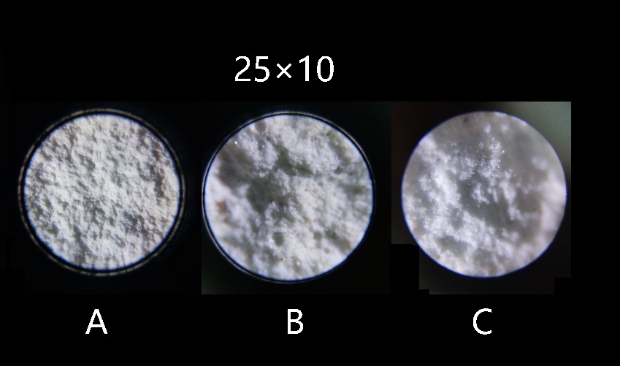
The fracture surfaces show out of three types of chalk, A has the most flat and uniform surface with nearly no impurities. The fracture surface of B is rocklike with small sags and is slightly porous. B is also shown with the most impurities. The fracture surface of C has small dimples and few impurities. This observation is consistent with the impact toughness of the material. For a more compact and uniform material that have few pores (such as chalk A), there will be a better degree of coherence and a larger stress is required for the cracks to form and propagate. For a material with more pores (such as Chalk B), cracks are more likely to form and propagate.

The effect of dropping height on chalk fracture
In this experiment, all three types of chalk are tested and the results are recorded. In order to control variables and to better study the relationship between fracture and drop height, only the results of the toughest (chalk A) and the most brittle material (chalk B) are presented and analyzed.
The following tables are the results of the experiment.
Table 5: Chalk A fracture behavior when changing dropping height
A | Test 1 |  |  | Test 2 |  |  | Test 3
Height/cm | Pieces | Ground angle/° | Fracture length/cm | Pieces | Ground angle/° | Fracture length/cm | Pieces | Ground angle/° | Fracture length/cm
20 | 1 | 20°-25° | / | 2 | 5°-10° | 4.8/3.2 | 2 | 10°-15° | 5.2/3.8
30 | 2 | 10°-15° | 4.2/3.2 | 2 | 10°-15° | 4.0/4.0 | 2 | 10°-15° | 4.8/3.2
40 | 1 | <5° | / | 2 | 15°-20° | 5.5/2.4 | 2 | 10°-15° | 4.3/3.7
50 | 2 | 25°-30° | 4.4/3.6 | 3 | 20°-25° | 3.6/3.2/1.2 | 2 | 30°-35° | 4.2/3.8
60 | 3 | 10°-15° | 3.6/3.3/1.1 | 3 | 15°-20° | 3.9/2.1/2.0 | 3 | 20°-25° | 4.8/2.3/1.9
70 | 4 | 5°-10° | 3.2/1.4/1.5/1.9 | 3 | 20°-25° | 3.7/2.8/1.5 | 3 | 20°-25° | 4.0/2.1/1.9
80 | 3 | 20°-25° | 3.0/2.6/2.4 | 2 | 60°-65° | 4.9/3.1 | 3 | 25°-30° | 4.2/3.5/0.4

Table 6: Chalk B fracture behavior when changing dropping height
B | Test 1 |  |  | Test 2 |  |  | Test 3
Height/cm | Pieces | Ground angle/° | Fracture length/cm | Pieces | Ground angle/° | Fracture length/cm | Pieces | Ground angle/° | Fracture length/cm
20 | 2 | 15°-20° | 5.7/2.3 | 2 | 15°-20° | 4.5/3.5 | 2 | 5°-10° | 4.3/3.7
30 | 2 | 45°-50° | 4.0/4.0 | 2 | 5°-10° | 5.0/3.0 | 2 | 5°-10° | 4.8/3.2
40 | 3 | <5° | 3.7/2.2/2.1 | 3 | 20°-25° | 3.0/2.7/2.3 | 3 | 15°-20° | 4.0/2.2/1.8
50 | 3 | 25°-30° | 3.1/3.0/1.9 | 3 | 20°-25° | 3.3/3.2/1.2 | 3 | 5°-10° | 2.7/2.7/2.6
60 | 4 | <5° | 2.2/2.1/1.9/1.8 | 3 | 15°-20° | 3.2/2.8/2 | 2 | 30°-35° | 4.1/3.9
70 | 3 | 15°-20° | 3.0/2.5/2.5 | 3 | 35°-40° | 4.0/2.2/1.8 | 3 | 60°-65° | 3.9/3.3/1.8
80 | 4 | 15°-20° | 2.2/2.1/1.9/1.8 | 3 | 5°-10° | 3.2/2.4/2.4 | 3 | 35°-40° | 3.9/2.1/2.0
The experiment results show chalk B begins to fracture with cascades at a height about 40 cm while chalk A begins to fracture with cascades at a height larger than 50 cm. At the same height, chalk A have a smaller number of fractured pieces than B, which is consistent with the results obtained from 4.1.
For single fractures, the chalk rods usually break roughly in half. For cascading fractures where the chalk is broken into three pieces, usually there appears to be a larger piece and two smaller pieces. The larger pieces of cascading fracture usually have a length roughly about half of the chalk.
The experiment result also show that the number of fracture pieces has an increasing trend as the dropping height increases. The researcher hence puts forward the following assumption:
For an idealistic situation where the frictional force applied by the air can be ignored, the speed of the center of mass of the chalk rods reaching the ground is given by the formula
(3)
The speed of chalk immediately turns to zero the instant it hits the ground.
The contact force exerted on the chalk is given by:
(4)
When the chalk reaches the ground, its kinetic energy is:
(5)
The equations (4) and (5) show that the impact given on chalk and the energy transferred will both increase with height.
By equations (4) and (5), and the number of pieces should be strongly correlated with the dropping height of chalk. However, this is not the case. The following diagrams show the analyses of correlation and linear regression between the fracture pieces
Fig 15. Linear regression of number of pieces of chalk A against drop height

Fig 16. Linear regression of number of pieces of chalk B against drop height

It is found that for the best regression light between the fracture pieces and height, it turns out to be a weak correlation with both R² < 0.5. Therefore, it is not convincing to conclude that the number of fracture pieces is only affected by dropping height for the same material of chalk. The researcher’s initial assumption is that the chalk would bounce and the change in kinetic energy will not be directly proportional to the dropping height. However, by looking over the slow-motion videos it is found that for a greater dropping height the speed of bounce is greater, thus the change in kinetic energy is greater and should result in more fracture pieces, thus the fracture pieces should increase, which is not consistent with the experiment results. By looking over the video recordings, the researcher noted that the ground angle for each drop would significantly vary and influence the cascading process. Therefore, an additional experiment is conducted to investigate the effect ground angle on fracture pieces.

The effect of ground angle on chalk fracture
In order to better control variables, this experiment only chose chalk A and was dropped at a fixed height of 50cm. The following table shows the results:
Table 7: Chalk A fracture behavior when changing drop angle
Height:50cm | Drop angle: 45° |  |  | Drop angle: 90°
Test number | Pieces | Ground angle/° | Fracture length/cm | Pieces | Ground angle/° | Fracture length/cm
1 | 2 | 30°-35° | 4.8/3.2 | 2 | 40°-45° | 4.1/3.9
2 | 2 | 60°-65° | 4.2/3.8 | 1 | 80°-85° | /
3 | 1 | 80°-85° | / | 1 | 75°-80° | /
4 | 3 | 10°-15° | 4.2/2.2/1.6 | 1 | 70°-75° | /
5 | 3 | 20°-25° | 4.6/2.0/1.4 | 2 | 45°-50° | 4.6/3.4
The researcher’s initial design was aimed to control and get a wider range of ground angles. However, the results show that there are no obvious relationships between drop angle and ground angle is not obvious, especially at a high drop height. This is due to the falling procedure is not idealistic and will be influenced by many factors such as air resistance and rotation. The results also show that the relationships between fracture and drop angle are small, thus it is more reasonable to study the relationship between fracture and ground angle.
The data is analyzed by correlation and linear regression. The results are as follows:
Fig 17. Linear regression of number of pieces of chalk A against drop angle

The results show that the ground angle plays a decisive role on the number of fracture pieces. In particular, the number of fracture pieces is strongly negatively correlated with the ground angle having an R² close to 1.
The failure/fracture Mechanism of chalk can be determined by observing the fracture processes and fracture characterizations of the material. By watching the slow-motion replays and observing fracture surfaces, it is found that the fracture process and fracture surface for different ground angles are significantly different.
For small drop angles, typical fracture characterizations of chalk are as follows:
Fig 18. Typical fracture characterizations for small drop angles
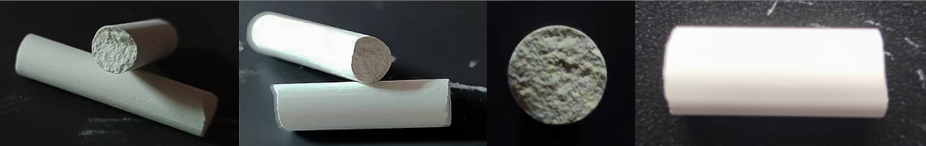
The fracture surfaces are approximately perpendicular to the major axis of chalk. This implies that the fractures of chalk are most likely to be caused by a tensile stress. Unsignificant facets are observed and the size of the facet tends to increase as the drop angle increases. This implies that a shear stress might also contribute to the fracture processes, and the effect of shear stress increases as the drop angle increases.
For large drop angles, typical fracture characterizations of chalk are as follows:
Fig 19. Typical fracture characterizations for large drop angles
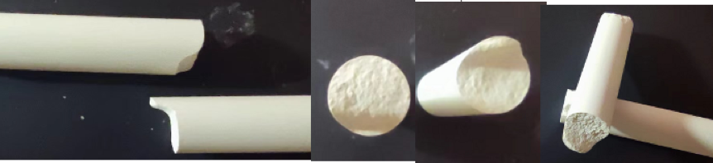
The fracture surfaces are uneven with a large facet on the side. This implies that for a large drop angle, the fractures are most likely to be caused by a shear stress.
Single fractures occur when the dropping heights are less than 40cm, regardless of ground angles. For dropping heights greater than 40cm, single fractures only appear when the ground angle is greater than 60° and the minimum ground angle needed increase with height. Fig 17 shows a typical single fracture at a lower drop height.
Fig 20. Fracture process of chalk B at height 30cm, ground angle 0°, test 1
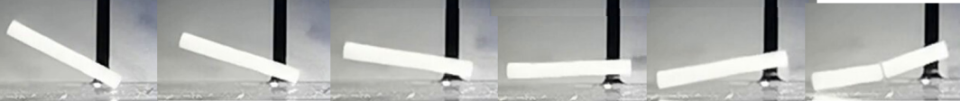
When chalk rods are dropped and with one end initially touching the ground, the ground experiences an impact force N (which is also a normal reaction force) pointing vertically upwards exerted by the ground and a gravitational force G pointing vertically downwards. The normal reaction force N can be decomposed into two components: Nx representing the component parallel to the axis and Ny representing the component perpendicular to the axis. The mathematical relationship between the components and N is given by Ny=Ncosθ and Nx=Nsinθ, where θ is the ground angle. Ny will provide a tensile stress and Nx will provide a shear stress. The effect of the tensile stress on the chalk rods can be shown by a bending moment M.
The normal reaction force is given by the formula (4).
The speed of chalk rods when hitting the ground increases with height. For lower dropping heights, N is small and Ny is unable to produce a bending stress larger than the maximum bending stress for chalk at any angle θ. Nx is also too small to produce a shear stress larger than the maximum shear stress of the material.
As a result of Ny, the chalk rod experiences a torque τ with respect to its center of mass for a very short time. The magnitude of τ is equal to Ny·d =N d cosθ. This torque gives the chalk rod an immediate acceleration , where I is the moment of inertia of the chalk rod. The point at the end of chalk rod will have an acceleration a=α×d. As a result, the other end of chalk hits the ground at a much greater speed than the first end, resulting in a larger normal reaction force between ground and the other end of chalk. If θ is small enough, the speed of the other end when hitting the ground will be able to create a normal reaction force that will result in a bending stress greater than the maximum bending stress of chalk, resulting the chalk to break. To summarize, the fracture is a result from acceleration of the other end caused by the torque provided by the impact force.
The following shows the forces, bending moments, torque and acceleration of the process.
Fig 21. Graphical interpretation of single fracture at low drop heights
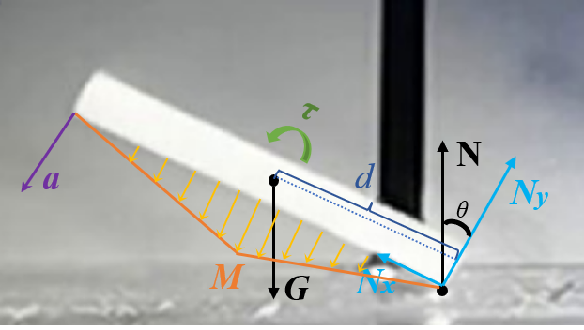
The fracture process of chalk will behave differently when it is dropped at a large height with a large ground angle θ. The following picture shows a typical single fracture at a high drop height.
Fig 22. Fracture process of chalk A at drop height 50cm, ground angle 90°, test 2
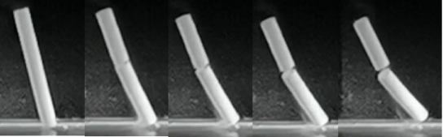
The chalk rod will break when the first end touches the ground. In this case, Ny has a small magnitude and is unable to produce bending moment greater than the maximum bending moment. In addition, τ is also small and fails to produce enough acceleration. The real contributor to the fracture process is Nx, which is large enough to produce a shear stress greater than the material’s maximum shear stress, causing the material to fail.
Fig 23. Graphical interpretation of single fracture at high drop heights
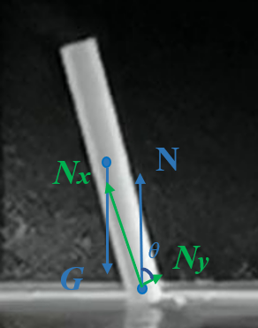

Interpretation of cascading fracture
Cascading fracture usually occurs at height greater than 50cm and a drop angle less than 60°. By observing the slow-motion videos, chalk does not break simultaneously into three or more pieces like elongated brittle rods. Chalk will initially break in half as a result of its first collision between the ground, and then the one end of the chalk will again fracture in half as a result of a second collision with the floor. The following pictures show a typical cascading fracture of chalk where the chalk breaks into three pieces.
Fig 24. Fracture process of chalk C at height 60cm, ground angle 0°, test 3
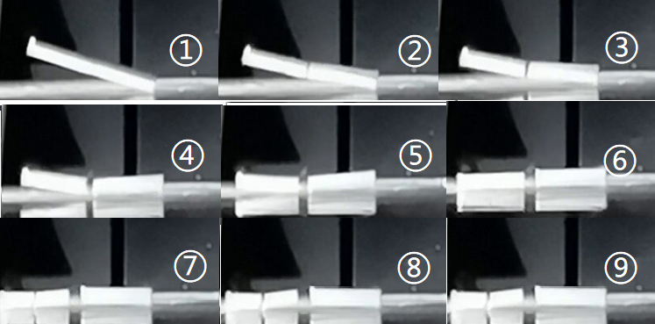
When the chalk hits the ground first, it instantly breaks roughly in half in response to its first impact, as ① and ② in fig 24 show. The chalk will receive a normal reaction force N that is greater than N at small heights because the instantaneous speed when having contact with ground is bigger. For such heights, Ncosθ (where θ represents the ground angle) is great enough to provide a tensile bending stress larger than the maximum tensile bending stress of chalk during the first contact.
Fig 25. Graphical interpretation of cascading fracture at first impact
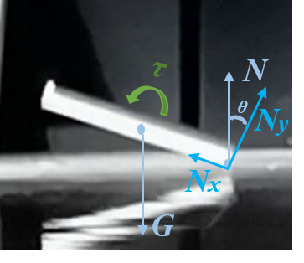
The impact force N will not only cause the chalk to fracture in half, but also will give the rod an instantaneous torque about its center of mass, τ. Thus, the other half will have an instantaneous acceleration, and the speed of the second mass is increased when hitting the ground.
Fig 26. Graphical notations of cascading fracture
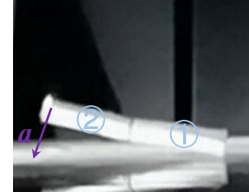
Let the piece with one end that hits the ground first be piece ① and the other end be piece ②, as fig 26 shows. Although the other end of piece one will hit the ground at a higher speed, the length of rod is reduced, thus it will produce a smaller bending moment. For most situations where drop height is between 50cm and 80cm, piece ① keeps intact.
When piece ② hits the ground, it hits the ground with one end initially. Since the length is reduced, the distance between the impact force N and the center of mass of the second chalk is reduced, therefore the contact force produces a smaller bending moment and a smaller torque. The bending moment and torque are also dependent on the angle between the axis and horizontal ground when hitting the ground. For most cases, the ground angle of piece ② will be smaller than 20°. If the bending moment cannot provide a bending stress greater than the maximum bending stress of chalk, piece ② will not break when one end hits the This ground first. Nevertheless, the other end of piece two accelerates again and will usually hit the ground with sufficient speed for the chalk to break. To summarize, when chalk fractures into three pieces, it is usually due to a direct impact caused fracture followed by a torque caused fracture.
Several cases have been observed where the chalk will break into four pieces, as the following figure shows:
Fig 27. Fracture process of chalk A at height 70cm, ground angle 0°, test 1
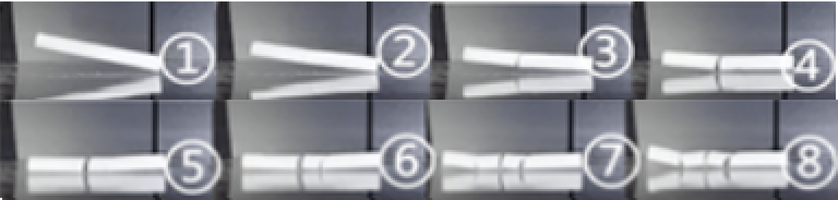
The rod will break into two pieces at its first impact with ground with mechanism same as the situation above, as ② and ③ in fig 27 shows. The fracture mechanism of piece ② is also the same as the situation above, as ⑤, ⑥ and ⑦ in fig 24 shows. The only difference in this situation is the fracture of the piece that hits the ground first. When the other end of this piece hits the ground, the speed is sufficient to produce a impact force that will cause the chalk to fracture under succeeded tensile bending stress. To summarize, when chalk fractures into four pieces, it is a nested process where a combination of direct impact caused fracture is followed by two torque caused fracture.
The cascading fracture is always a nested process where the fractured pieces fracture again when having contact with the ground. The more subordinary the fractures are, the more difficult it is to achieve. This is because the length of chalk gets shorter exponentially every fracture, thus the impact force required for the chalk to break will be increasing at an exponential rate.
In daily conditions where blackboard chalk is dropped in classrooms, the fractures will cascade since the drop heights are usually greater than 50cm and the drop angle is not likely to be near 90°.

Conclusion
This research determines the factors influencing the fracture behavior of brittle chalk rods. Based on the experimental results containing the fracture surface observation and fracture process recording, the researcher puts forward a brief theoretical interpretation of all the common fracture behaviors for chalk.
Three factors influence the fracture process: Chalk material, drop height and drop angle. Materials with greater impact toughness begin to fracture at a higher drop height. Dropping at the same height, materials with greater impact toughness break into less pieces. The fracture surfaces of chalks in different materials are observed under a microscope and related to its material properties. Flatter and more uniform material has a greater impact toughness since they have a better degree of coherence. Chalk usually breaks into two pieces when drop height is between 20 cm and 50 cm while suffers cascading fracture (break into three or more pieces) when drop height is greater than 50 cm. The fracture ground angle plays a decisive role in the fracture process. At the same height, the number of pieces of chalk is negatively correlated with the ground angle.
The fracture surface for different ground angles implies that the fracture is caused by tensile stress when the drop angle is smaller than 60°. On the other hand, when the ground angle is greater than 60°, the fracture is likely caused by shear stress. The video records show that one end of chalk always hit the ground firstly. When drop height ranges from 20 cm to 50 cm, chalk does not fail at the first contact with ground, but fail at the subsequent hit between the other end and ground with a higher angular velocity by rotating itself due to a torque produced from the first hit. When chalk drops at a height greater than 50 cm with a ground angle greater than 60°, chalk fail due to the shear stress produced in the first contact with ground.
When chalk drops at height greater than 50 cm, the fractured pieces break again, which results in cascading fracture. In most cases, chalk breaks into three pieces, which fractures twice in the whole process. Interestingly, the first fracture occurs when chalk hit the ground, which breaks the chalk into two pieces. After that the fractured piece which hits the ground at the beginning keeps intact, however, the other piece suffers another impact on the ground which breaks it into two pieces. Cases with chalk fractures into four pieces at a drop height greater than 70 cm and drop angle smaller than 30° see more complicated fracture behaviors as recorded by video.
Fracture morphology obtained by using optical microscopes gives direct evidence on fracture behavior for different cases. The flat fracture surface indicates that tensile stress dominates the fracture while tortuous fracture surface suggests that shear stress plays a key role in the fracture process.

Review and Evaluation
In this project, I wanted to know and be able to explain why chalk does not always break in half when dropped onto ground. At first it seemed to be an easy task to deal with and I have planned to conduct the experiments and analyze the results in a very short time. However, as I dug deeper into this unique phenomenon, it is very complicated and requires much knowledge about material mechanics and fracture mechanics that only knew little previously. The experiment obtained about 200 sets of data that I need to process. In order to cope with these problems, I adjusted by previous unconscionable plans. In addition, I learnt the knowledge needed in this project by reading textbooks and articles, and watching public classes online.
In this study, I studied how to choose a topic for research, how to search for and evaluate resources, how to design and conduct a complete experiment and so much more. I realized the importance of combining experiments and theoretical knowledge and have improved by skills of efficiently self-studying new knowledges. This unique fracture process tells me that physics is beautiful, and lies within every corner of our daily lives.

References
Audoly, B., & Neukirch, S. (2005). Fragmentation of rods by cascading cracks: Why spaghetti does not break in half. Physical review letters, 95(9), 095505.
Bartlett, A. A. (1975). Falling chimney apparatus modification. The Physics Teacher, 13(7), 435-437.
Bartlett, A. A. (1976). More on the falling chimney. The Physics Teacher, 14(6), 351-353.
Bell, F. G. (1977). A note on the physical properties of the chalk. Engineering Geology, 11(3), 217-225.
Callister, W. D., & Rethwisch, D. G. (2018). Materials science and engineering: an introduction (Vol. 9). New York: Wiley.
Chavan, H., Ghodke, P., Hatkar, S., & Nagare, N. (2020). Design and Fabrication of Automatic Dustless Chalk Making Machine (No. 2488). EasyChair.
Courtney, Thomas (2005). Mechanical behavior of materials. Waveland Press, Inc. pp. 6–13.
Cotton, D. W. K., Whitehead, C. L., Vyas, S., Cooper, C., & Patterson, E. A. (1994). Are hip fractures caused by falling and breaking or breaking and falling? Photoelastic stress analysis. Forensic science international, 65(2), 105-112.
Cottrell, A. H. (1958). Theory of brittle fracture in steel and similar metals. Trans. Met. Soc. AIME, 212.
Ewalds, H. L., & Wanhill, R. J. H. (1984). Fracture Mechanics, Edward Arnold and Delftse Uitgevers Maatschappij. London, UK and Delft, The Netherlands.
Fabricius, I. L. (2007). Chalk: composition, diagenesis and physical properties. Bulletin of the Geological Society of Denmark, 55, 97-128.
Field, J. E. (1971). Brittle fracture: its study and application. Contemporary Physics, 12(1), 1-31.
Heisser, R. H., Patil, V. P., Stoop, N., Villermaux, E., & Dunkel, J. (2018). Controlling fracture cascades through twisting and quenching. Proceedings of the National Academy of Sciences, 115(35), 8665-8670.
Hinrichsen, P. F. (2021). The physics of falling chimney stacks. Physics Education, 56(5), 055023.
Huang, Y. Q., Hu, S. W., & Sun, Y. Y. (2019). The effect of inner friction on concrete fracture behavior under biaxial compression: a 3D mesostructure study. Materials, 12(23), 3880.
Knigh, R. D. (2007). Physics for Scientists and Engineers: A Strategic Approach with Modern Physics.
Lord, J. A., Clayton, C. R. I., & Mortimore, R. N. (2002). Engineering in chalk. Ciria.
Madsen, E. L. (1977). Theory of the chimney breaking while falling. American Journal of Physics, 45(2), 182-184.
LESOIN, L., CRAMPON, C., BOUTIN, O., & BADENS, E. (2011). Colloids and Surfaces A: Physico-Chemical and Engineering Aspects.
Mortimore, R. N., Stone, K. J., Lawrence, J., & Duperret, A. (2004). Chalk physical properties and cliff instability. Geological Society, London, Engineering Geology Special Publications, 20(1), 75-88.
Shimizu, S., Tsuchiya, K., & Tosha, K. (2009). Probabilistic stress-life (PSN) study on bearing steel using alternating torsion life test. Tribology Transactions, 52(6), 807-816.
Tan, A. (2015). Comment on chalk breaking. The Physics Teacher, 53(4), 196-196.
Thakker, M., Shukla, P., & Shah, D. O. (2015). Surface and colloidal properties of chalks: A novel approach using surfactants to convert normal chalks into dustless chalks. Colloids and Surfaces A: Physicochemical and Engineering Aspects, 480, 236-244.
Varieschi, G., & Kamiya, K. (2003). Toy models for the falling chimney. American Journal of Physics, 71(10), 1025-1031.
Vandegrift, G. (1997). Transverse bending waves and the breaking broomstick demonstration. American Journal of Physics, 65(6), 505-510.
Vollmer, M., & Möllmann, K. P. (2011). Exploding balloons, deformed balls, strange reflections and breaking rods: slow motion analysis of selected hands-on experiments. Physics Education, 46(4), 472.
Rao, Q., Sun, Z., Stephansson, O., Li, C., & Stillborg, B. (2003). Shear fracture (Mode II) of brittle rock. International Journal of Rock Mechanics and Mining Sciences, 40(3), 355-375.
Young, H. D., Freedman, R. A., & Ford, A. L. (2013). University Physics with Modern Physics Technology Update. Pearson Education.

